ZABBIX-RUNDECK

Lab-Guide

**www.zippyops.com**

209/210, 1st floor, J Nagar

Panaiyur Kuppam Road,

Panaiyur, Chennai-600119

****[**zippyops@gmail.com**](mailto:zippyops@gmail.com)

**+91 7010585768**

Project Name: MONITORING SERVICE

STATUS

# Overview

In this project we are going to monitor the SERVICES in Linux and Windows machines by using Zabbix and Zabbix-agent. The Zabbix will trigger the rundeck Job when a Service is dead. Then the Inline Script in rundeck job will restart particular service.

# 1.ZABBIX:

## 1.Add HOST in zabbix server like this:

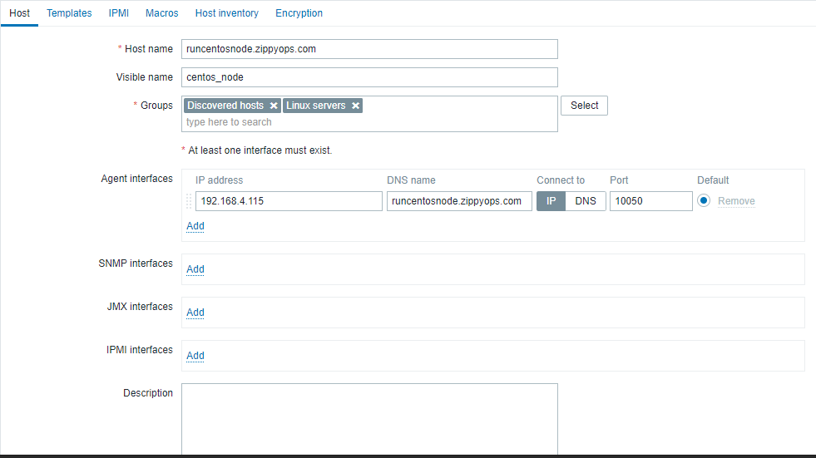

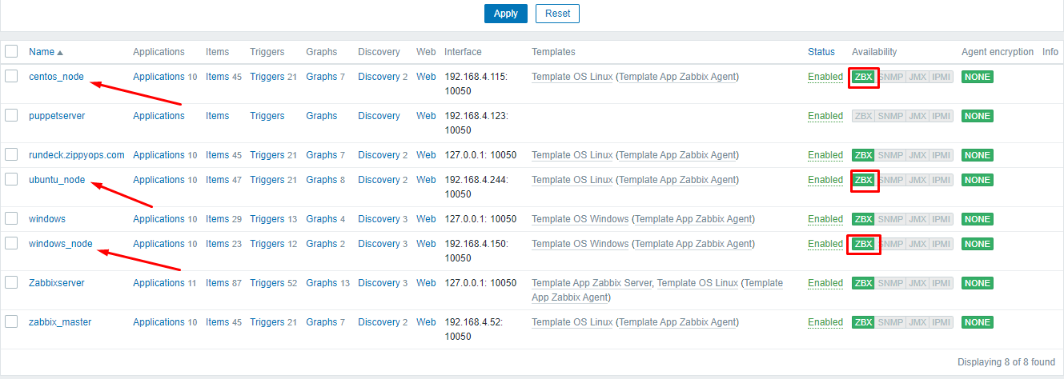

## 2. Create a Trigger for Service Status:(Linux & Windows).

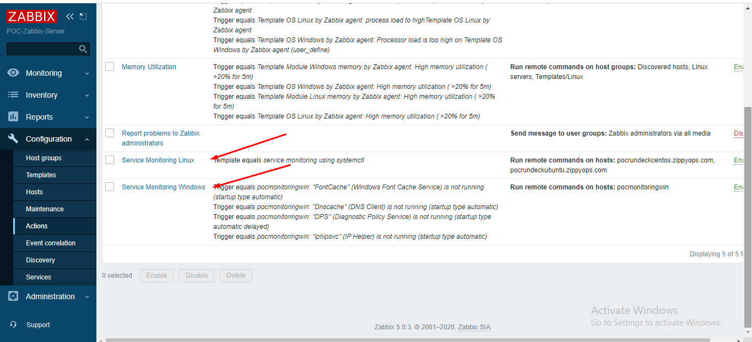

## 3 Create an Action for Service Status and add condition.

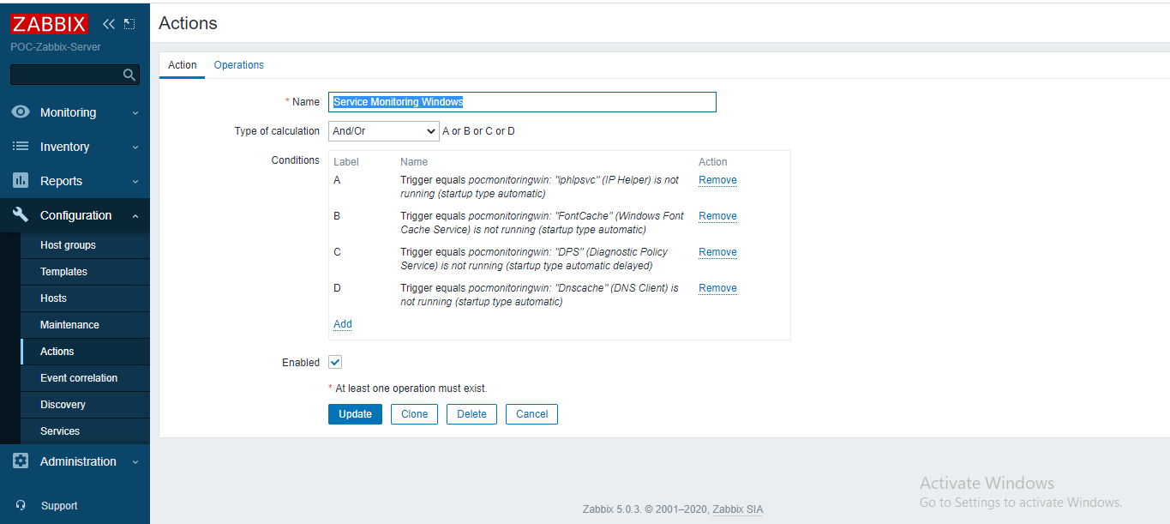

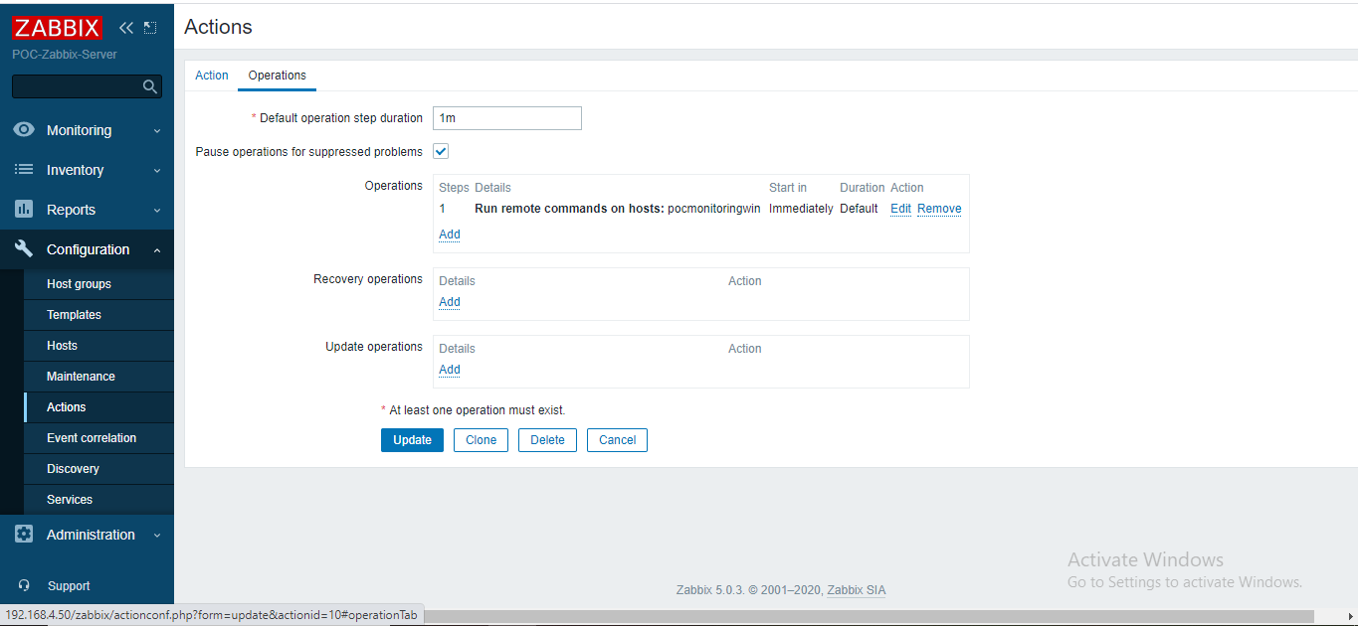

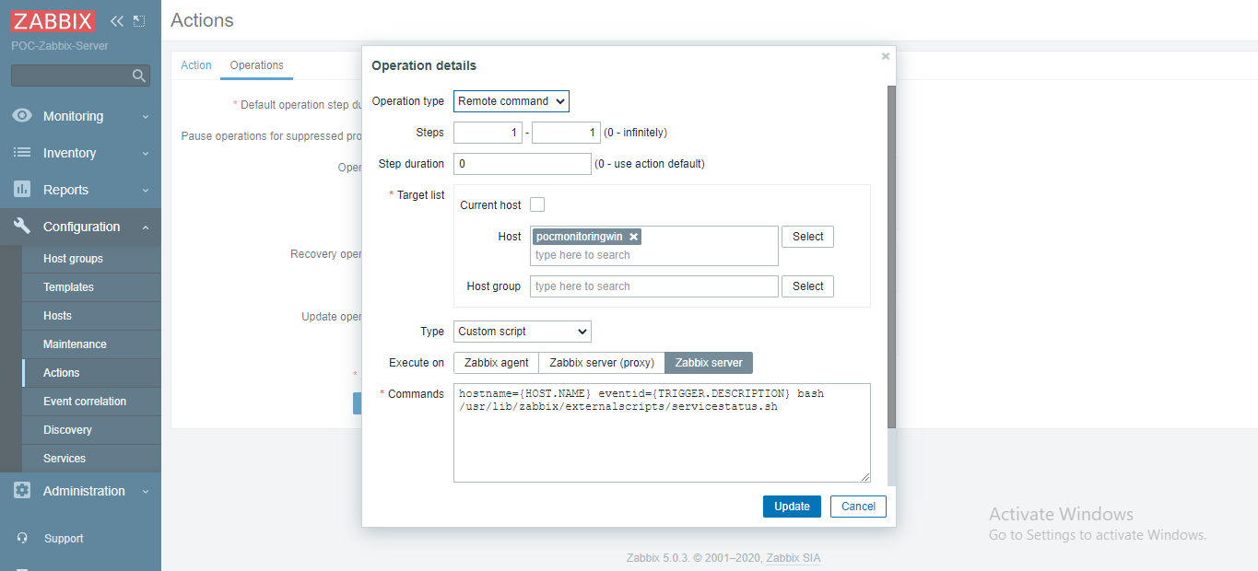

Same operation settings for Linux by selecting linux hosts in Host column.

# 2.RUNDECK:

## 1. Create a Project for Monitoring Service Status:(Linux & Windows).

### **LINUX:**

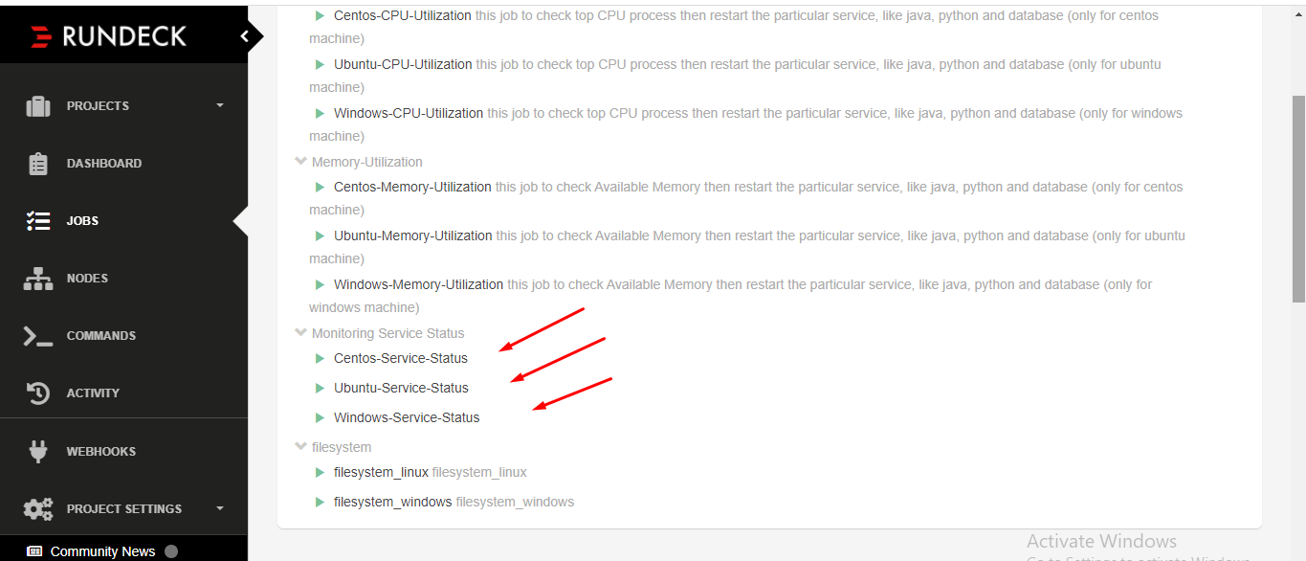

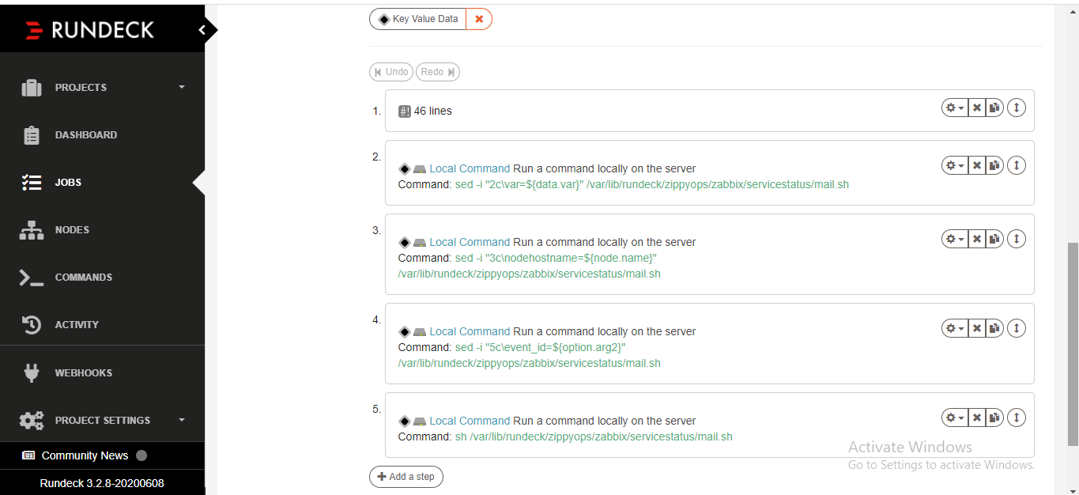

### **WINDOWS:**

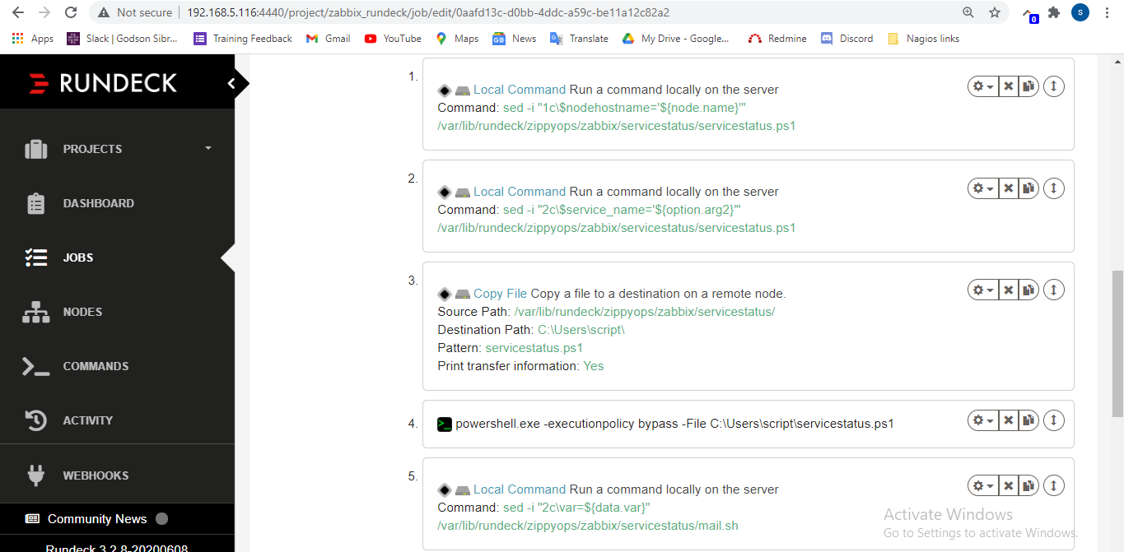

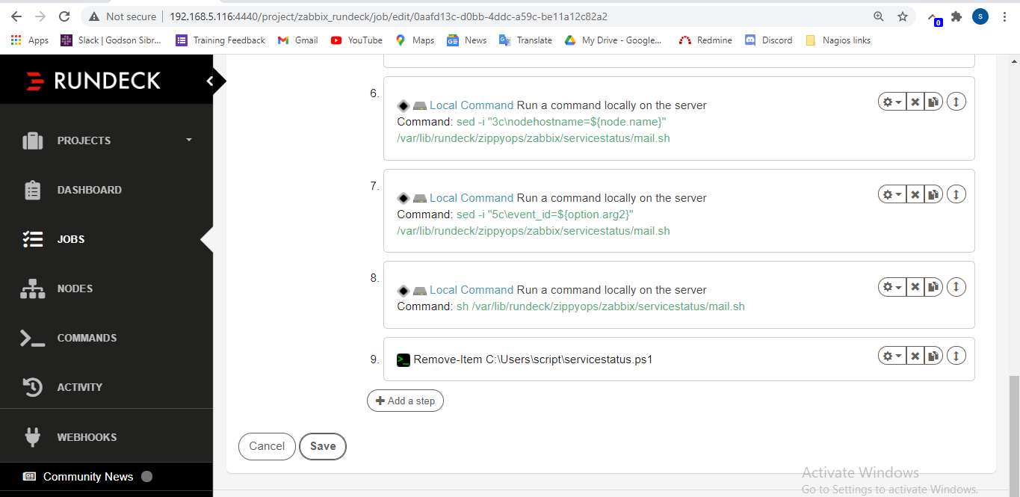

## LINUX SCRIPT:

**nodeostype=@node.os-name@**

**HOSTNAME=@option.arg1@**

**SERVICENAME=@option.arg2@**

**echo "$nodeostype"**

**echo "$HOSTNAME"**

**echo "$SERVICENAME"**

**if [ "$nodeostype" == "centos" ]; then**

**echo "This is linux machine 192.168.4.115"**

**if [ "$SERVICENAME" = "sshd" ]**

**then**

**systemctl restart sshd**

**var="$SERVICENAME"**

**echo "$var"**

**sleep 5**

**echo "this is $SERVICE"**

**elif [ "$SERVICENAME" = "httpd" ]**

**then**

**systemctl restart httpd.service**

**var="$SERVICENAME"**

**echo "$var"**

**echo "this is $SERVICENAME"**

**sleep 5**

**elif [ "$SERVICENAME" = "$SERVICENAME" ]**

**then**

**systemctl restart $SERVICENAME**

**var="$SERVICENAME"**

**echo "$var"**

**echo "this is $SERVICENAME"**

**sleep 5**

**elif [ "$SERVICENAME" = "crond" ]**

**then**

**systemctl restart crond**

**var="$SERVICENAME"**

**echo "$var"**

**echo "this is $SERVICENAME"**

**sleep 5**

**else**

**echo "not for this"**

**var="$SERVICENAME"**

**echo "$var"**

**echo "this is $SERVICENAME"**

**fi**

**fi**

**echo "var=$var"**

## WINDOWS SCRIPT:

**$nodehostname='windowsnode'**

**$service_name='iphlpsvc'**

**if ($nodehostname -eq "windowsnode"){**

**Restart-Service -Name $service_name**

**echo "Restarting Service $service_name"**

**$var="$service_name"**

**echo "var=$var"**

**}**

**else{**

**echo "BYE"**

**}**

## MAIL SCRIPT:

**#!/bin/bash**

**var=httpd**

**nodehostname=centosnode**

**mail=alerts@zippyops.in**

**event_id=httpd**

**if [ $nodehostname == centosnode ]; then**

**if [ $var == crond ]; then**

**echo "$var service running on $nodehostname" | mail -s "$var Service Restarted on Centos node" $mail**

**elif [ $var == httpd ]; then**

**echo "$var service running on $nodehostname" | mail -s "$var Service Restarted on Centos node" $mail**

**elif [ $var == ssh ]; then**

**echo "$var service running on $nodehostname" | mail -s "$var Service Restarted on Centos node" $mail**

**elif [ $var == $var ]; then**

**echo "$var service running on $nodehostname" | mail -s "$var Services Restarted on Centos node" $mail**

**else**

**echo "this is not $nodehostname"**

**exit 0**

**fi**

**elif [ $nodehostname == ubuntunode ]; then**

**if [ $var == cron ]; then**

**echo "$var service running on $nodehostname" | mail -s "$var Service Restarted on Ubuntu node" $mail**

**elif [ $var == java ]; then**

**echo "$var service running on $nodehostname" | mail -s "$var Service Restarted on Ubuntu node" $mail**

**elif [ $var == apache2 ]; then**

**echo "$var service running on $nodehostname" | mail -s "$var Service Restarted on Ubuntu node" $mail**

**elif [ $var == $var ]; then**

**echo "$var service running on $nodehostname" | mail -s "$var Service Restarted on Ubuntu node" $mail**

**else**

**echo "this is not $nodehostname"**

**exit 0**

**fi**

**elif [ $nodehostname == windowsnode ]; then**

**if [ $var == System ]; then**

**echo "$var service running on $nodehostname" | mail -s "$var Service Restarted on Windows node" $mail**

**elif [ $var == httpd ]; then**

**echo "$var service running on $nodehostname" | mail -s "$var Service Restarted on Windows node" $mail**

**elif [ $var == python ]; then**

**echo "$var service running on $nodehostname" | mail -s "$var Service Restarted on Windows node" $mail**

**elif [ $var == $var ]; then**

**echo "$var service running on $nodehostname" | mail -s "$var Service Restarted on Windows node" $mail**

**else**

**echo "this is not $nodehostname"**

**exit 0**

**fi**

**fi**